Assignment-4

Assignment 4: Compose SQL statements to BEGIN a transaction, INSERT a new record into the 'orders' table, COMMIT the transaction, then UPDATE the 'products' table, and ROLLBACK the transaction.

Orders Table & Products Table:
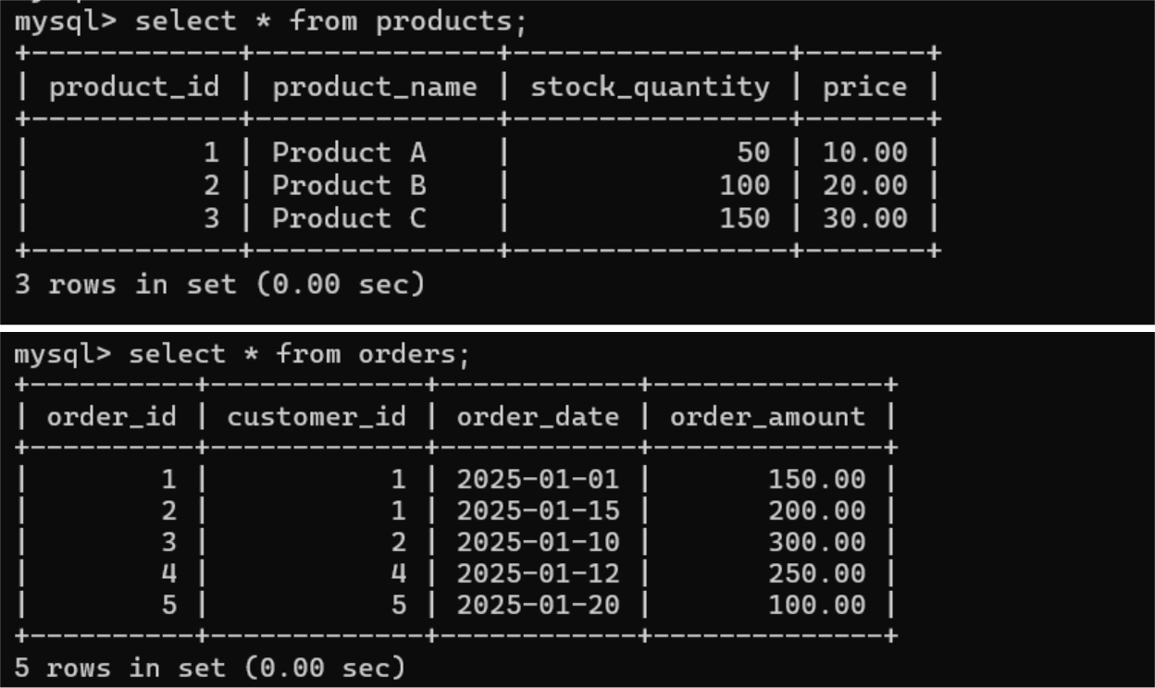

Begin Transaction and Insert a New Record into orders:
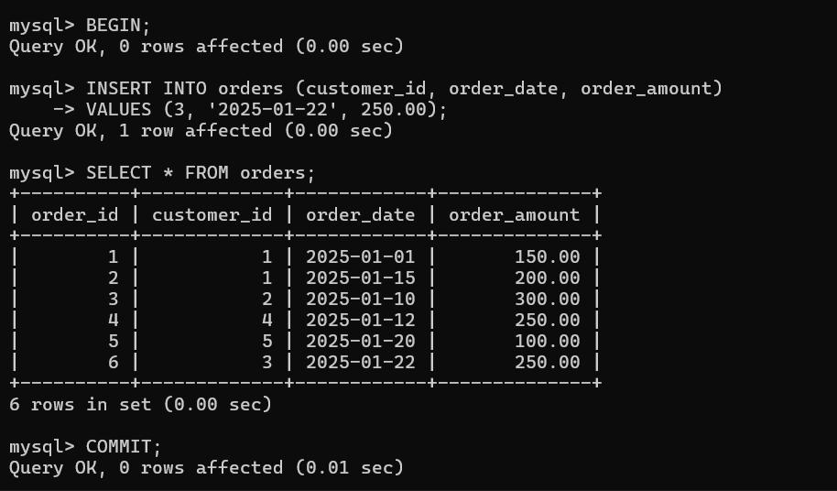

Begin Another Transaction, Update products, and Rollback:
